**ASE 374L SPACECRAFT MISSION DESIGN**

**P.R.O.P.H.E.C.Y**

PRecise OPerations for High Efficiency Communication sYstems



**Final Report**

Carlos Barreto

Lauren Cooper

Caleb Ngai

Shaid Rojani

Zachary Tschirhart

Macon Vining

May 2, 2014

The Department of Aerospace Engineering and Engineering Mechanics

The University of Texas at Austin

Austin, TX 78712

Contents

Executive Summary 5

List of Figures 7

List of Tables 7

List of Acronyms 7

1.0 Introduction 8

1.1 Project Motivation 8

1.2 Heritage Missions 9

1.2.1 LLCD (LADEE) 9

1.2.2 RACE 10

1.2.3 Delfi-n3Xt 10

1.2.4 CSTB1 11

1.2.5 MAST 11

1.3 Mission Concept of Operations 11

1.3.1 Launch 12

1.3.2 Deployment and Orbit 13

1.3.2.1 Deployment 13

1.3.2.2 Orbit 14

1.3.2.3 Relative Motion Trajectory Analysis 17

1.3.3 Checkout 20

1.3.4 Sat-Sat LaserCom 20

1.3.5 Earth LaserCom 21

1.3.6 Extended Operations 21

1.3.7 Re-Entry 21

2.0 Mission Scope 22

2.1 Need Statement 22

2.1.1 Assumptions 22

2.1.2 Limitations 22

2.2 Requirements 22

2.2.1 Mission Level Requirements 22

2.2.2 System Level Requirements 23

2.2.2.1 Launch Vehicle 23

2.2.2.2 Orbit and Trajectory 24

2.2.2.3 Subsystem Requirements 24

3.0 Design Approach 27

3.1 Command and Data Handling 27

3.1.1 Design Candidate Selection 27

3.1.2 Real Time versus non-Real Time Operating System Trade Study 27

3.2 Communication System 28

3.3 Attitude Determination and Control 29

3.3.1 Selection Criteria 29

3.4 Power Subsystem 30

3.4.1 Selection Criteria 31

3.5 Structure and Thermal 32

3.6 Payload 33

4.0 Design Details 37

4.1 Baseline Design 37

4.2 Final Design Description 37

4.2.1 Command and Data handling 37

4.2.2 Attitude Determination and Control 38

4.2.3 Power Subsystem 39

4.2.4 Communication Subsystem 42

4.2.5 Structure and Thermal Subsystem 43

4.3 Mass Breakdown 44

4.4 Power Budget 44

4.5 Volume Breakdown 46

4.6 Risk Analysis 47

4.7 Cost Estimation 49

5.0 Summary and Conclusions 51

6.0 Evaluation of Overall Design6.1 Strengths 53

7.0 References 54

8.0 Appendices 55

8.1 Team Structure and Organization Chart 55

8.2 Individual Team Member Contributions 55

8.3 Team Member Resumes 57

# Executive Summary

This document contains a proposal of a near-earth CubeSat mission to serve as a demonstration of high efficiency Laser Optical Communication using high precision Attitude, Determination, and Control (ADC) systems in order to meet the specific pointing accuracies required to operate in a free-space environment.

The PRecision OPerations for High Efficiency Communication sYstems (PROPHECY) mission was created to demonstrate that high ADC accuracy and precision in swiftly developed, low-cost satellites can adequately meet the needs of future communications networks without significant detriment to mission budgets, be that time or monetary constraints. State-of-the-art Free-Space Optical Laser Communication (LaserCom) technologies will be used to analyze and quantify the specifications of the ADC system. LaserCom requires pointing accuracies on order of tens of arcseconds - equivalent to a few thousandths of a degree.

Due to the multiple pitfalls of current Radio Frequency (RF) technologies (such as limited bandwidth, interference, large power losses, and bottlenecking of data) there is a need for a more efficient and powerful method of communication. LaserCom fulfills those needs - and then some. With no bandwidth limitations, virtually no interference in free-space applications, and 10 -100 times the data efficiency of current RF technologies - LaserCom has proven to be the ideal candidate.  NASA intends to employ the Tracking and Data Relay Satellites (TDRS) with LaserCom upgrades for near-earth and atmospheric communications.

Based on the NASA statement “The next generation in communications satellites will supply both [Radio Frequency (RF)] and optical services.” [Laser Comm Relay], the PROPHECY mission has been suggested in order to prove that CubeSats can become a viable alternative to larger satellites and provide the same level of communication support in near-Earth missions. Using the discoveries of the Laser Communication Relay Demonstration (LCRD), a mission designed to demonstrate the effectiveness of laser communication from the moon, PROPHECY aims to demonstrate and prove that CubeSats are capable of providing a standard LEO/GEO platform for future near-earth laser communication needs with quick development at low-costs.

Lastly, as satellites become more prevalent in the use of everyday technology, the nature of the CubeSat as a rapidly-developed and easily replaceable satellite becomes more enticing. This mission stands to prove that highly efficient communication and data relay satellites can be produced and deployed on a short timeline, while maintaining the efficiency and efficacy of a the previously larger satellites.

In summary, PROPHECY aims to prove the ability of CubeSats to act as reliable short-term satellites for Free-Space, high-atmosphere, and ground communications at a fraction of the production time and cost of current state-of-the-art communications satellites.

# List of Figures

|  |  |
| --- | --- |
| Figure 1: PROPHECY Concept of Operations 9  Figure 2: Subsystem Trade Tree 18  Figure 3: Layout of Subsystems within Structure 21  Figure 4. Team Structure and Organization 26 |  |

# List of Tables

Table 1. AHP for Operating Systems 14

Table 2: Selection Criteria for Heritage ADC Systems 16

Table 3: Power System Options 17

Table 4: Structural Materials Comparison 17

Table 5. Mass Budget 22

Table 6. Power Budget 22

Table 7. Volume Budget 22

# List of Acronyms

ADC – Attitude Determination and Control

C&DH – Command & Data Handling

COM – Communication

BOL – Beginning of Life

FPGA – Field Programmable Gate Array

IMU – Inertial Measurement Unit

ISS – International Space Station

J-SSOD – JEM Small Satellite Orbital Deployer

LaserCom – Laser Communication

LEO – Low Earth Orbit

OCL – Optical Communication Laser

PROPHECY – Precise Operations to Produce Highly Efficient Communication Systems

RF – Radio Frequency

TRL - Technology Readiness Level

UHF – Ultra High Frequency

VHF – Very High Frequency

# Introduction

## Project Motivation

As technology progresses and becomes more complex, the data obtained from this technology grows exponentially in size. This increased data size creates a problem for satellite communications, as the data transfer is often bottlenecked by the bandwidth of radio frequencies. Specifically, in the realm of nanosatellites, there does not yet exist a laser communication system for these nanosatellites to communicate with other satellites or to establish a groundlink. Furthermore, cube satellite missions are becoming increasingly popular due to the high scientific return at a much lower cost than a large satellite mission. The increased popularity of cube satellites in the university setting as well as the professional setting is the inspiration for this mission. Due to this widespread use, precise communication between cube satellites, larger satellites, the international space station, and ground stations, has become increasingly important. Thus, there exists a need to create a low power and high bandwidth laser communication system that can be used in space while meeting the volume, power and mass requirements for CubeSats. A laser transmitter and receiver can provide ten to one-thousand times the data rate of typical radios, while also providing the added benefits of more secure communication as it is difficult to intercept. By eliminating the losses incurred from wave propagation and unfocused power with traditional radio transmissions, laser communication becomes an important step in removing the communication bottleneck.

PRecision OPerations for High Efficiency Communication sYstems (PROPHECY) is intended to test and improve the efficiency of highly precise communication on cube satellites by utilizing precision attitude control and a laser based transmitter and receiver. This objective will be accomplished by utilizing heritage missions to meet power and radio communication requirements and a combination of attitude control techniques for augmented attitude control. When using lasercom, precise attitude control systems are necessary, requiring arcseconds of accuracy. In order to test the ability to communicate efficiently and reliably using a laser communication systems embedded inside two CubeSats, the mission will include a fully autonomous satellite-to-satellite laser communication and ends with a lasercom connection with a laser terminal ground station.

This mission seeks to prove the effectiveness and feasibility of laser communication in nanosatellites and can help pave the way for creating large constellations of cube satellites capable of handling large amount of data.

|  |  |
| --- | --- |
|  |  |

## Heritage Missions

Although CubeSats have existed for less than two decades, there have already been numerous missions. The following programs show the current state of CubeSat technologies. PROPHECY will build upon the success of these missions and expand the work that they have accomplished.

### LLCD (LADEE)

The Lunar Laser Communication Demonstration was a laser demonstration aboard the LADEE spacecraft and was a mission conducted by NASA Goddard Space Flight Center and Ames Research Center. The LLCD mission used an optical laser to transmit data from a lunar orbit to a groundstation at 622 Mbps using a pulsed modulation communication scheme. This was completed using 137 Watts of input power and a transmit power of 5 Watts. This is extremely relevant to the PROPHECY mission because it helps establish our communication profile, our groundstation contacts, and lastly it helps establish the stringent power requirements for a CubeSat platform of less than 30W for laser input power.

### RACE

The Radiometer Atmospheric CubeSat Experiment (RACE) is a science mission partnership between NASA Jet Propulsion Laboratory and UT-Austin Texas Spacecraft Laboratory. The mission is to place a 183 GHz radiometer in low earth orbit. The reason this mission is especially interesting to PROPHECY, is because it has nearly identical size and power constraints as PROPHECY does, and it also uses the TSL’s modular CubeSat design by dividing up the satellite into 3 separate sections; Service (1 Unit), Attitude Determination and Control (0.5 Units), and Science/Technology Payload (1.5 Units).

### Delfi-n3Xt

The Delfi-n3xt was a triple unit CubeSat that was developed by Delfi Space and launched on November 21, 2013 [1]. Its main objective was to demonstrate the utilization of particular propulsion and communication systems that would be viable options for future missions. Of said systems, the communication system and electrical power subsystem are most pertinent to the PROPHECY mission. The Delfi-n3xt CubeSat used a Primary Transceiver (PTRX) and ISIS Transceiver (ITRX) as a redundant set. The antenna system was arranged such that it would have an almost omni-directional pattern. This would ensure operational communications regardless of the CubeSat’s attitude. The Delfi-n3xt also use solar cells as its main source of power and incorporate the TEC1D triple junction cells from TECSTAR. The solar arrays are deployable and assume a specific configuration in order to maximize efficiency. The solar panels are attached to the top of the CubeSat’s body and are deployed at an optimized angle.

### CSTB1

Boeing’s CubeSat Test Bed 1 (CSTB1) was launched on April 17, 2007 into a 750 km sun-synchronous orbit [4]. The objective of this particular mission was to test the performances of several newly innovated components and subsystems for cubesats. Of these subsystems, the CSTB1’s attitude determination system is of great interest towards this proposed mission. The attitude determination subsystem utilizes a collection of sun sensor suites coupled with two-axis magnetic field sensors. Four panels of the CSTB1 are equipped with a sun sensor suite. Each suite has two photodiodes that have an overlapping response curve, which allows it to determine the sun vector. There is a magnetic field sensor installed in five of the six panels. From the data determined by the arrays of sensors, the attitude of the CubeSat can be calculated by using an Attitude Determination Algorithm.

### MAST

The Multi-Application Survivable Tether (MAST) mission was launched on April 17, 2007. Its main objective was to test a particular deployable tether technology for CubeSats [2]. Of the subsystems used, the command and data handling subsystem is pertinent to the PROPHECY mission. The MAST CubeSat utilized a MicroChip PIC 18F8720 processor due to its lightweight and relatively low-power requirements. The processor was used for adequate interfaces for the mission, and also supported the GPS unit which was used for attitude determination.

## Mission Concept of Operations

The PROPHECY mission is comprised of six crucial operational milestones with the possibility of additional extended operations. A visual representation of the concept of operations (ConOps) is shown below in Figure 1.

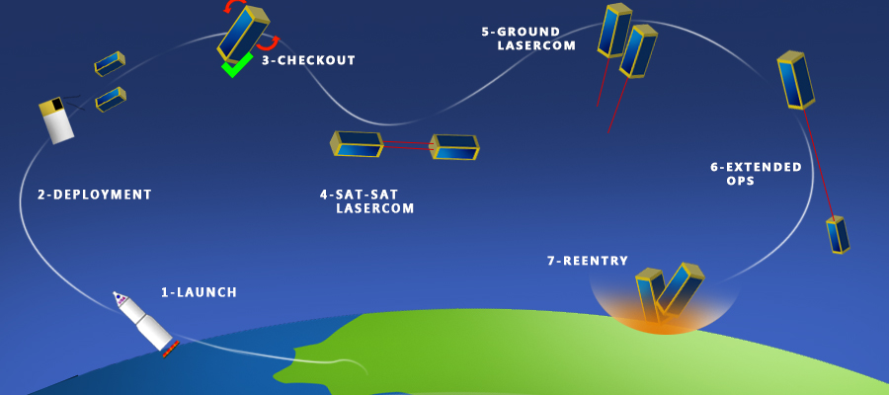

Figure : PROPHECY ConOps

The mission will consist of Launch, P-Pod Deployment, a Systems Checkout, Sat-Sat LaserCom, Earth Laser Com, possible Extended Operations, and Re-entry. Each stage of the mission is defined in detail in the following subsections.

## Launch

PROPHECY will be launched on board the secondary payload of an International Space Station (ISS) ISS resupply mission as part of the CubeSat Launch Initiative. The launch date will be flexible since the satellite can be on board the secondary payload of any rocket headed to the ISS. The two CubeSats, PROP1 and PROP2, are each pre-installed within a deployment mechanism vehicle called a Poly-Picosatellite Orbital Deployer (P-Pod). The P-Pod protects the CubeSat from external environmental hazards until the time of deployment when the spring loaded mechanism releases the CubeSat off the internal guiderails. The spring-loaded device is pre-programmed to jettison the satellites at a specific insertion velocity. The P-Pods are installed and mounted directly onto the secondary payload in an orientation specific to deployment requirements. PROP1 and PROP2 will be deployed in the opposite direction of forward motion, directed 45-degrees from the NADIR-axis in the NADIR-AFT quadrant of the vertical plane of the Body-Fixed Coordinate System of the cargo vehicle. This deployment configuration will create a minimum ballistic coefficient of 120 kg/m3 ensuring that there is no chance for ISS collision.

## Deployment and Orbit

## Deployment

The CubeSats will be deployed using Poly-PicoSatellite Orbital Deployers (P-PODs) created by Cal Poly University. The P-POD is a deployment system that protects the CubeSat from external environmental hazards until the time of deployment when a spring-loaded mechanism releases the CubeSat off of internal guiderails within the casing. The spring-loaded device is pre-programmed to jettison the satellites at a specific insertion velocity. PROP1 and PROP2 are each installed in a separate P-Pod casing, which is then mounted directly onto the secondary payload in an orientation specific to deployment requirements. At release, each P-POD is pointed 45 degrees from both the AFT and NADIR axes in the NADIR-AFT plane of the Body-Fixed Coordinate System of the secondary payload vehicle. This configuration releases the CubeSats opposite of the direction of motion of the launch vehicle. Once in position, springs located in the release mechanisms on the P-Pod case will release the CubeSat at a pre-determined velocity. PROP1 and PROP2 will be jettisoned at 1.15 and 1.1 m/s, respectively. PROP2 will be deployed after a 2 minute delay to allow for adequate initial distance between CubeSats so as to avoid collision from variable drag forces incurred during checkout maneuvers.

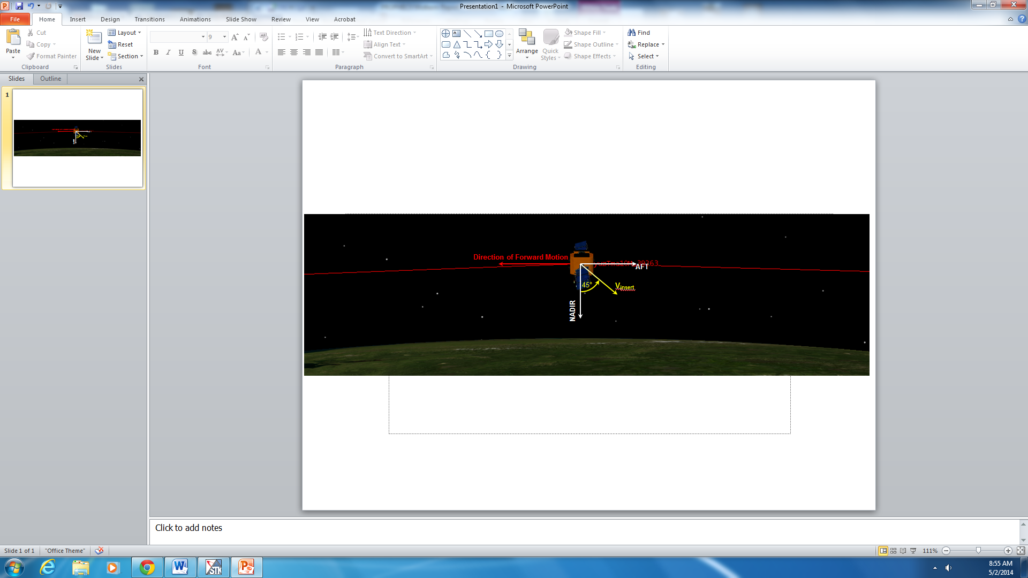

Figure : Deployment Configuration.   
(View is from Port side of SOYUZ – Along negative Y-Axis towards frame origin in SOYUZ Body-Fixed Coordinate System.)

The downward orientation deployment increases drag by creating a ballistic coefficient of β=135 kg/m2. Along with the downward deployment, the drag increase ensures that semi-major axis decay of the CubeSat orbits will allow a minimum of a 10 kilometer difference in orbital altitude at time of closest approach with the ISS, ensuring collision avoidance. Once in position, spring mechanisms on the P-Pod case will jettison PROP1 and PROP2 into orbit at 1.15 and 1.1 m/s, respectively. (See Section 1.3.2.1 for Relative Motion Trajectory Analysis for an in-depth look at velocity decision.) PROP2 will be deployed after a 5 minute (300 second) delay to allow for an initial distance of .43 ± .005 km between CubeSats so as to avoid collisions between the two caused by variable drag forces incurred during checkout maneuvers. These results were found using the trajectory analyses described below. (See Section 1.3.2.3 for Relative Motion Trajectory Analysis for an in-depth look at velocity decision.)

## Orbit

Once a deployment method that best optimized the length of the mission and its corresponding operational windows was chosen, parameters were established using the deployment details of insertion orientation.

Using a Two-Line Element (TLE) of the Zarya Module of the International Space Station provided by the North American Aerospace Defense Command (NORAD), it was possible to verify the Orbital Elements of the ISS provided by NASA. These elements are assumed to be analogous with a cargo vehicle on approach to the ISS, which is when the CubeSats will be deployed. Using an element conversion algorithm, rotation matrices were employed to convert the Keplerian orbital elements to Cartesian state vector components of position $\overset{⃑}{r}$, and velocity $\overset{⃑}{v}$, in the Earth Centered Inertial (ECI) Coordinate Frame, where

$\overset{⃑}{r}= 〈 r_{x},r_{y},r_{z} 〉$& $\overset{⃑}{v}= 〈 v_{x},v_{y},v_{z} 〉$

From these vectors, the relative jettison velocities were found to calculate the resulting orbital trajectories of the two CubeSats over the lifetime of the mission.

It should be noted that these state vectors are representative of the orbital motion of the vehicle from which the CubeSats will be deployed. For the motion of the two satellites in relation to each other, separate analyses were conducted to find the resulting relative positions.

The equations of motion for a two-body system including atmospheric drag perturbations were used for the trajectory analyses.

Drag calculations were based off of a ballistic coefficient calculation such that $β=m/{C_{D}A}$. The chosen coefficient of drag, $C_{D }=2.2$, was found to be the average value of forty seven standard 3U CubeSats placed in orbit since 2003. [Oltrogge] The area calculation, *A* was calculated using a planform area calculation based on the assumption of a 10o maximum pointing angle from the long axis between the CubeSats during satellite-to-satellite communications. (See Relative Motion Subsection for calculation.) Lastly the maximum mass - including all added margins – was used, $m=4 kg.$ This yielded a ballistic coefficient of $β=135 {kg/m}^{2}$.

These results yielded decay rates acceptable for each operational window. As shown below in Figure 3, the change in semimajor axis will cause nearly 100 km decay in orbital altitude over the lifetime of the mission. This requires higher angular rates for ground LaserCom passes, and thus necessitates more days to passively create larger distances between the satellite and the ground station in order to achieve manageable turning rates. Although this requires more time, it is still possible to accurately and successfully achieve ground communication.

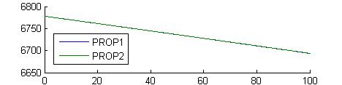

Figure : Change in semi-major axis due to atmospheric drag (km) over 100 solar days.

Insertion velocities were chosen in order to optimize the allotted time for each operation. Due to the fact that check out can take up to two weeks, that necessitated a longer window of opportunity for laser communication within the 500 km range. Because power constraints only allow for ~2 tests per day, passive movements were needed that allowed for a wide range of distances.

In addition to maximizing the amount of time the CubeSats were within the satellite-to-satellite testing range, it was necessary to optimize the potential for successful extended operations. (Extended operations for the PROPHECY mission include satellite-to-satellite LaserCom tests at distances larger than the 500 km range. In order to allow for the possibility of extended operations, the two CubeSats ought not to move outside of the maximum line of sight. At the specified orbital altitude, the maximum line of sight – while still avoiding the dense lower atmosphere – was found to be 4,000 km. Therefore, the insertion velocities were chosen so that windows of time the CubeSats were within each range were maximized.

Lastly, due to the restricted number of possible ground stations capable of LaserCom satellite-to-ground communications (As shown below in Figure #) there was a maximum of two possible tests per day, due to pass over issues and geographical restrictions. As seen in the ground tracks for one solar day – which have a precession of about 5-degrees per day, this restricts the number of possible tests to a maximum of two tests per day. Taking into account the possibility of inclement weather and high angular rates during passovers, there needed to be at least 14 days for ground testing.

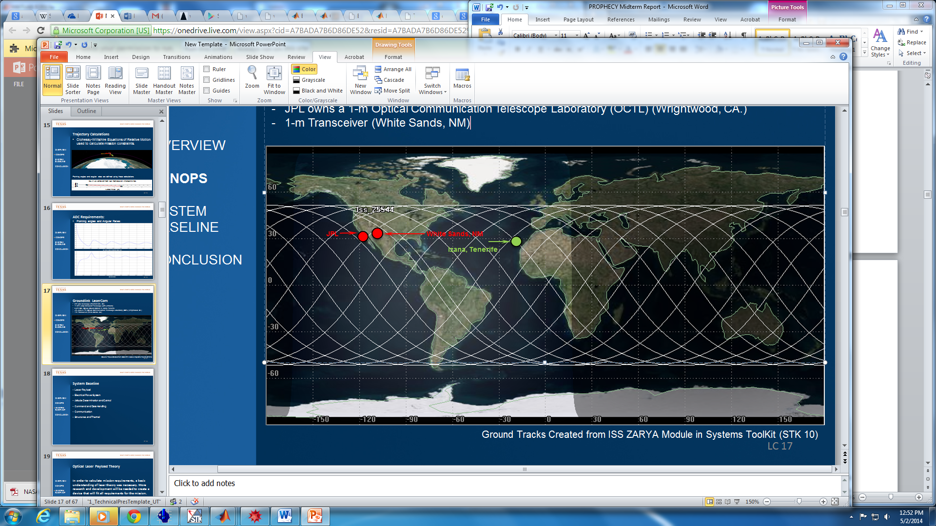

Figure : LaserCom Ground Station Terminals

Due to these issues, along with a maximum lifespan of 100 days, the choice was made to attempt split the windows of time for satellite-to-satellite and satellite-to-ground/extended operations almost equally, in order to optimize the amount of time in each operational period.

In doing so, the insertion velocities of PROP1 and PROP2 were chosen to be 1.15 and 1.1 m/s, respectively. This is due to the fact that first and foremost the CubeSats remain in the satellite-to-satellite range for 54.34 days, and remain within sight of eachother for the entirety of the mission. Secondly, this allows at least 40 days for ground communication and extended operational testing.

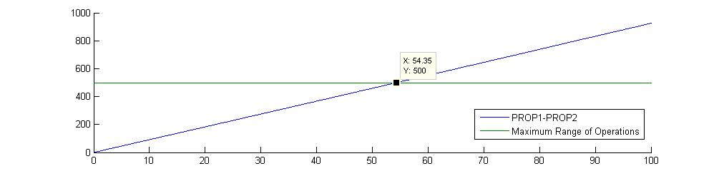

Figure : Relative Distance between CubeSats (km) as a function of Time (solar days)

At higher insertion velocities for PROP1, it was not optimal to both maintaining line of sight between the two CubeSats and attempt to maximize the time allotted for payload testing.

## Relative Motion Trajectory Analysis

The P-POD deployment configuration – explained in detail in the previous section – allows for relative orbital motion calculations between PROP1, and PROP2. This orbital trajectory analysis was possible using the Clohessi-Wiltshire (CW) equations of relative motion. This method was decided due to extensive CW analysis heritage information from the GRACE mission of dual satellite relative motion, which also required sub-degree pointing accuracies over comparable distances (GRACE: 250 km, PROPHECY: 500 km). No other dual-satellite configurations match our mission architecture parameters as closely as GRACE.

In order to calculate the relative motion of the satellites, a second algorithm was used which used the CubeSat jettison velocities to evaluate the CW equations. See Appendix # for the full Clohessy-Wiltshire Equations. From these equations, the relative motion of the satellite and their corresponding relative distances were calculated.

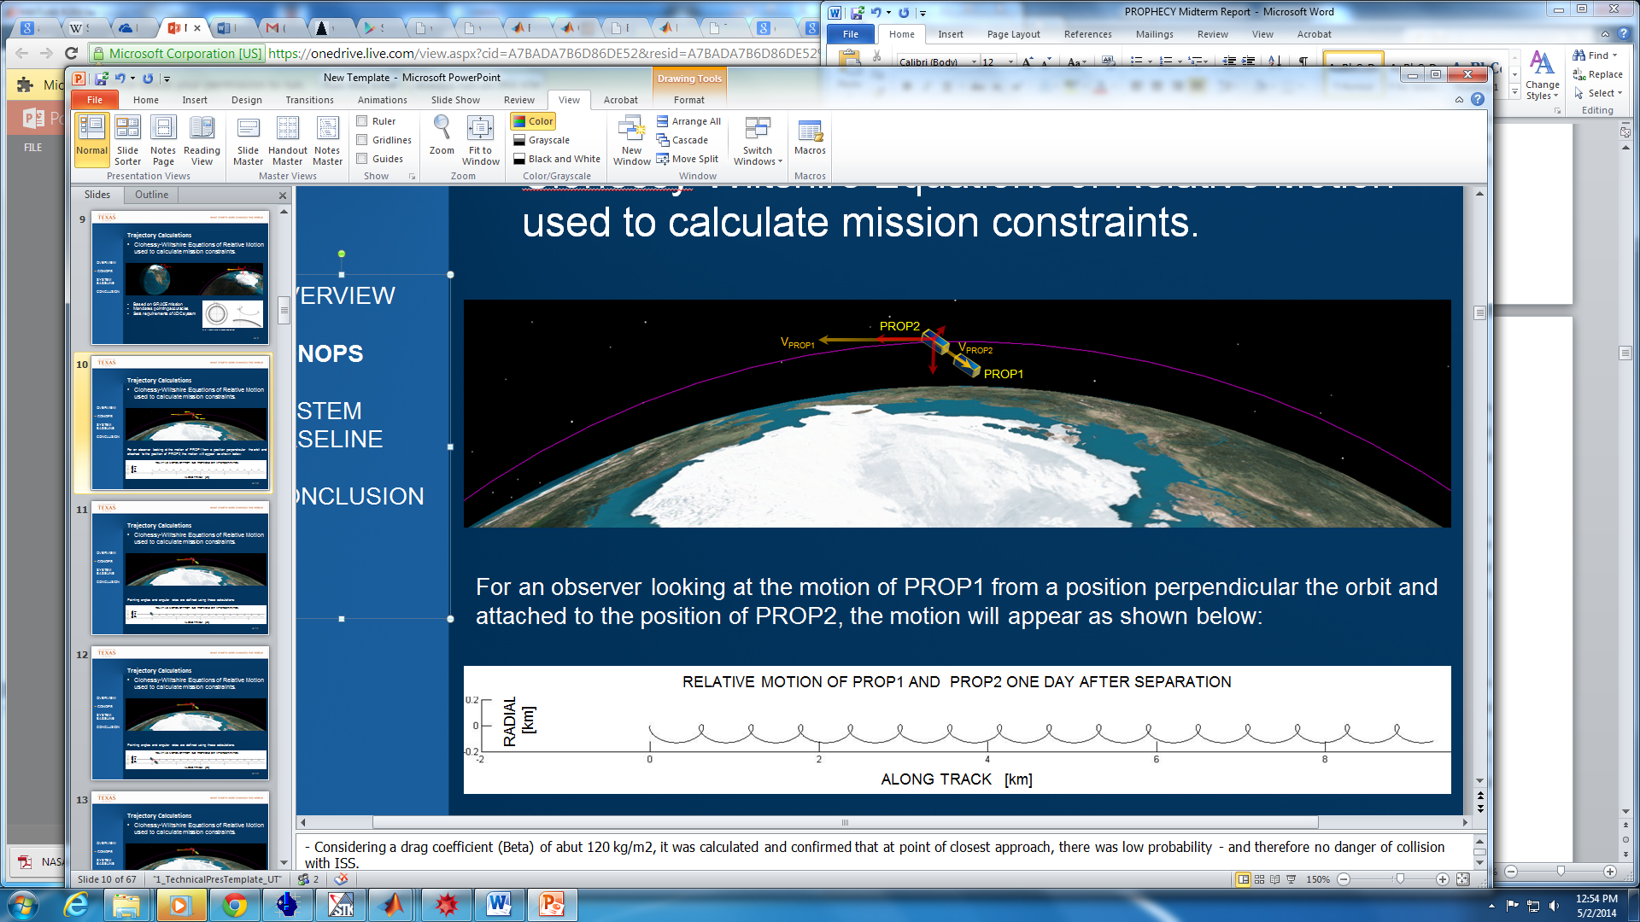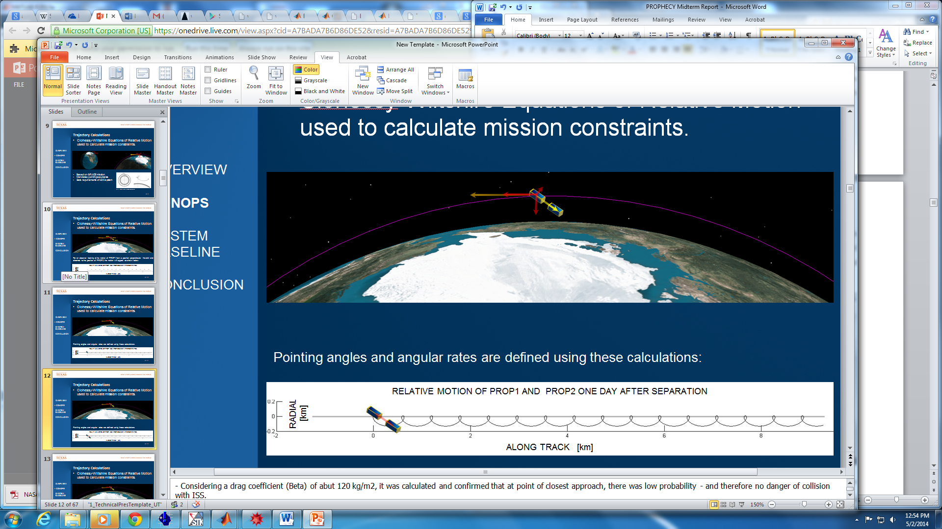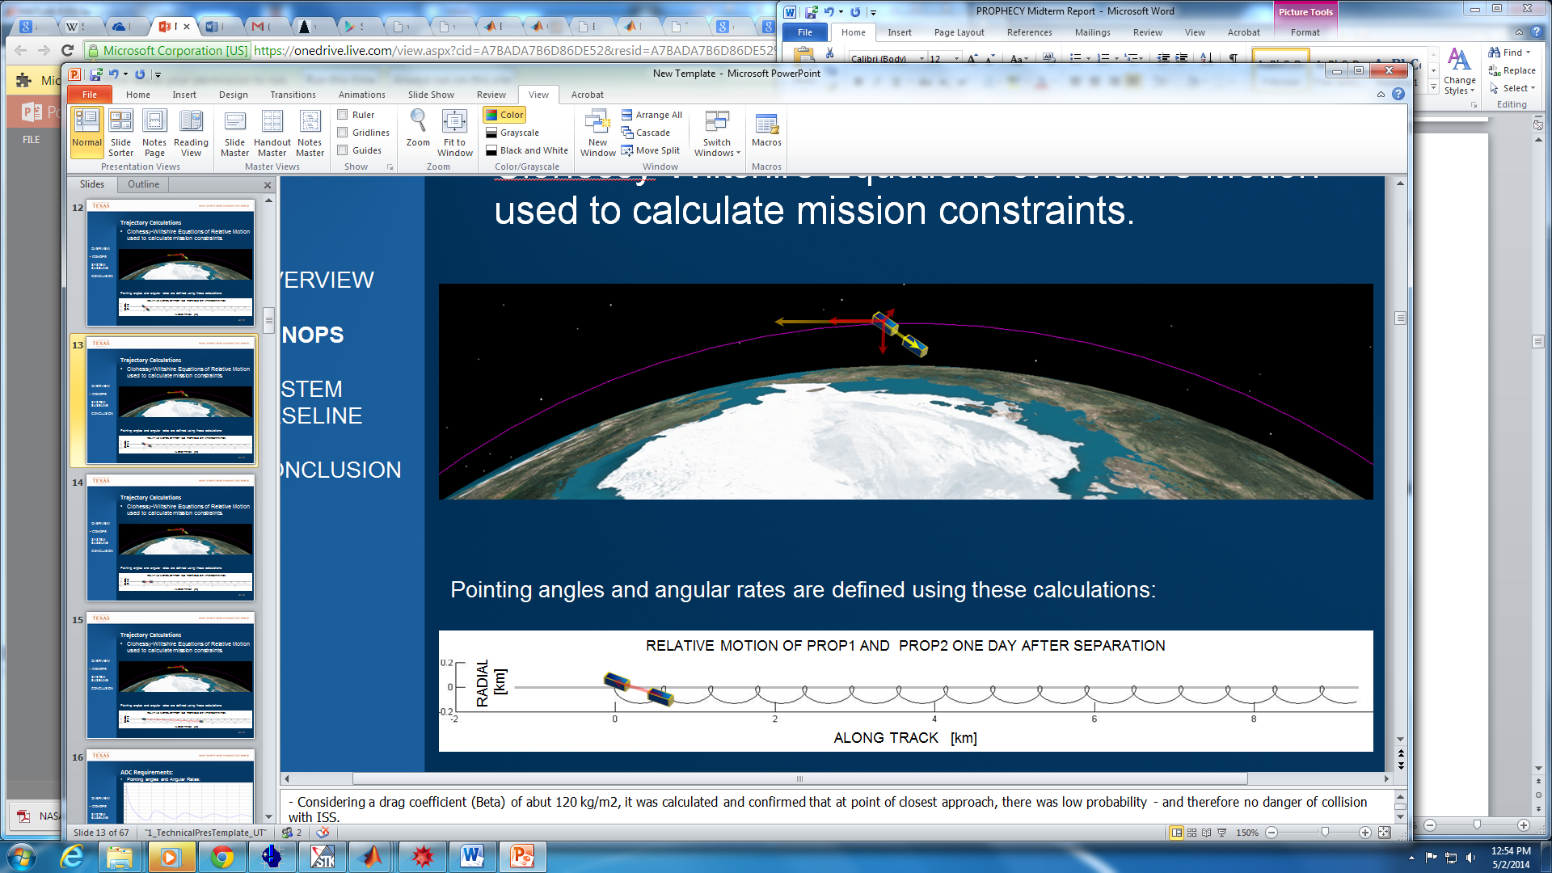

Figure : Relative Motion of PROP1 and PROP2 one solar day after jettison.

For an observer looking at the motion of PROP1 from a position perpendicular the orbit and attached to the position of PROP2, the motion will appear as shown above in Figure 6. Assuming PROP1 is stationary at the origin, the motion of PROP2 relative to PROP1 is calculated. In the figure, the pointing angle is depicted as the angle between the pointing line and the local horizontal axis (of PROP1). Each curved semi-circular movement is an orbital period. As PROP2 moves from the origin along the plotted flight path trajectory, it is shown that the pointing angle oscillates. As PROP2 nears the horizontal axis, the pointing angles are at a minimum, and as it follows each loop, the angle grows. However, this angle is bounded at the maximum angle required within the first orbital period, and the angle decays as it moves further along the trajectory. With each orbital period the pointing angle decreases, and converges to zero. These angles are shown below in Figure 7.

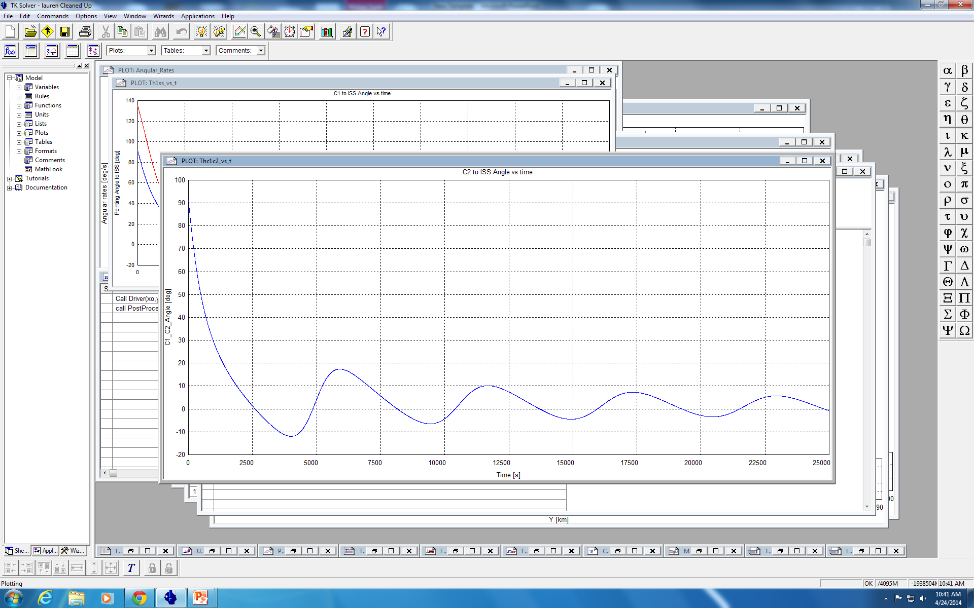

Figure : Pointing angle requirements (deg) for PROP1 over the first 25000 seconds.

The real importance is in the angular rates required to maintain the pointing angles. Shown below in Figure 8, the pointing angles are compared against the angular rates for the first 25000 seconds after jettison (~1/3 day). This short time span is important because it indicates the time it takes to converge upon an angular rate which PROPHECY’s attitude control system is capable of handling. Therefore, within the first third of a day, the required angular rates are within 0.01 degrees/sec, and checkout can begin almost immediately after jettison – within the first ten minutes, 1200 seconds.

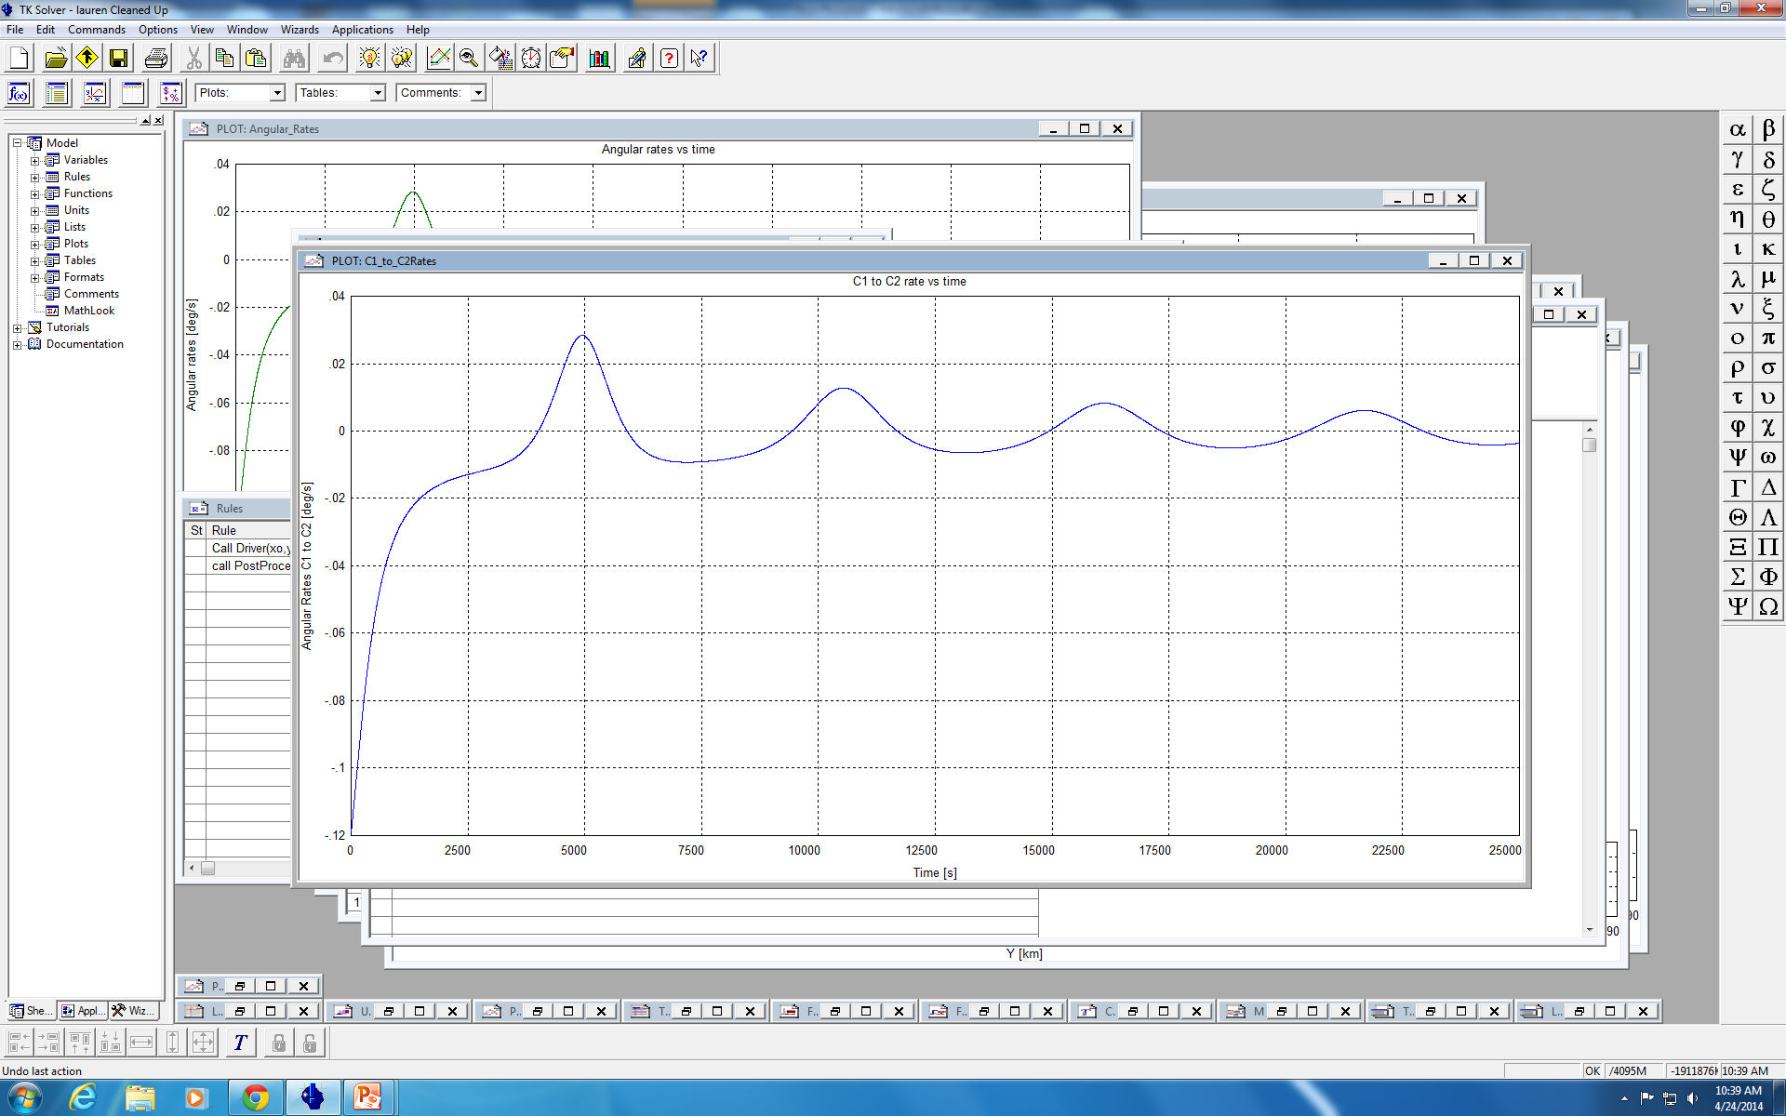

Figure : Angular Rate requirements (deg/s) for PROP1 over first 25000 seconds.

Using these results, the pointing requirements mandated by the orbital motion were then compared to the pointing capabilities of the ADC system. Also, the angular rates at which the CubeSats needed to move were compared to the control capabilities of the system. Both of these calculations were used to check PROPHECY’s ability to meet the requirements set by both the LaserCom payload and the relative motion.

It should also be noted that as PROP1 must turn to maintain pointing accuracy with PROP2, PROP2 must also turn these same angles and rates in order to maintain axial pointing with PROP1. This is because the LaserCom necessitates that the long axis of both CubeSats need always be aligned within a 0.008o offset. Therefore, both systems must simultaneously follow the controls described above.

## Checkout

After being deployed, the PROP1 and PROP2 will perform initial checkout procedures. This consists of a flight systems check to validate proper operation of all onboard systems and verification of satellite communication with the operating station via the onboard radio. After a complete system checkout, attitude determination, calibration, and alignment will occur. Onboard reaction wheels will be used for active attitude control, and torque rods will be used passively, primarily to ensure desaturation of the reaction wheels. This period will last anywhere from 1-14 solar days.

## Sat-Sat LaserCom

At this point, both satellites will begin the SAT-SAT (satellite-to-satellite) communication. This involves the fully autonomous operation of pointing the lasers and receivers of the PROPHECY CubeSats toward one another and initiating lasercom. Once again, large and small data strings will be transmitted and received between satellites in order to verify the signal connection, this period will cease after approximately 40 solar days.

## Earth LaserCom

At this point, the satellites will point their lasers toward Earth and attempt ground station communication. The ground station locations will be in White Sands, NM, at NASA/JPL’s Table Mountain Facility in Wrightwood, CA, and at La Teide Observatory in Spain’s Canary Islands.

## Extended Operations

Upon successful completion of Stage 5, the satellites will begin Stage 6, which consists of Extended Operations. The purpose of Extended Operations is to test the maximum distance at which PROP1 and PROP2 are capable of communicating with one another, while maintaining a bit rate of at least 350Mbps

## Re-Entry

After Extended Operations have been completed, the PROPHECY satellites will reorient themselves in a high-drag configuration in order to facilitate deorbit.

# 2.0 Mission Scope

## 2.1 Need Statement

The PROPHECY mission is designed in order to determine the effectiveness of laser communication in a low-cost and low-power platform such as a CubeSat.

## Assumptions

This mission requires the following assumptions:

* Heritage missions are relatable
* Research and development of all technologies will be completed and certified by the launch date
* The launch vehicle will be an ISS resupply mission

## 2.1.2 Limitations

• Monetary budget – limited to under $5 Million. This maintains the standpoint that the mission will be relatively low cost.

• Mass constraints – Each CubeSat will need to be under 4kg in total mass. This is dictated by the CubeSat Launch initiative.

• Volume constraints – All subsystems of the CubeSat will need to fit within a 3U ISISPod deployment system. This grants 10x10x30cm of available space within the CubeSat.

* Power constraints – All subsystems of the CubeSat will need to be run purely off of power absorbed from the solar panels and stored in on-board batteries.

## 2.2 Requirements

The requirements for the PROPHECY mission consist of five mission-level requirements and eight system-level requirements. These are in place to ensure mission success and feasibility.

### 2.2.1 Mission Level Requirements

1. *Both PROPHECY satellites shall be launched as a secondary payload on a resupply mission to the ISS under the CubeSat Launch Initiative.*

The most inexpensive and reliable option for reaching LEO with an inclination of 51.6 degrees is to utilize a secondary payload.

1. *Both PROPHECY satellites shall be deployed into orbit using a P-Pod deployment system.*This is to ensure that both CubeSats are deployed into the correct orbit before reaching the ISS.
2. *The mission shall have two primary optical laser communication tests. The CubeSats shall initiate lasercom with one another other and a ground station.*   
   These two tests will give a full understanding of the efficiency of the optical laser communication system.
3. *Both PROPHECY satellites shall conform to the dimensions of a 3U (unit) CubeSat.*This requirement provides a standard from which mass, volume, and power requirements will be derived.
4. *The Payload module of both PROPHECY CubeSats shall house a laser transmitter and receiver specifically for experimental laser communication.*This requirement establishes the necessity of a laser in each CubeSat for the sake of redundancy and to provide satellite-to-satellite laser communications.

### 2.2.2 System Level Requirements

### 2.2.2.1 Launch Vehicle

1. The CubeSat shall be delivered to LEO upon any ISS resupply mission with availability in the secondary payload and by utilizing the CubeSat Launch Initiative.

*Rationale: Due to the low cost of the mission and relative low priority when compared to larger missions, this mission will begin whenever a launch opportunity is available.*

1. The PROPHECY CubeSats will be transported inside of protective housings, namely P-Pod deployers.

*Rationale: This exists in order to keep the spacecraft safe in transit and the overall form factor small.*

### 2.2.2.2 Orbit and Trajectory

1. The orbital altitude of the CubeSats will be at an altitude of 380-420 km with an inclination of 51.6 degrees, but shall not interfere with any ISS operations.

*Rationale: Altitude and inclination of the orbit is determined entirely by the nature of the launch.*

1. - The velocity of the CubeSats will be 1.15 m/s for the first deployed satellite and 1.1 m/s for the second deployed satellite.

*Rationale: This is to guarantee that the CubeSats will move apart from one another at a slow rate.*

### 2.2.2.3 Subsystem Requirements

1. The spacecraft shall provide a 3.3V and 5V bus for which all subsystems will draw their power.

*Rationale: This reduces overall complexity of the electrical system and allows for all subsystems to run off of the same power source.*

1. The mass of each individual 3U CubeSat shall not exceed 4kg.

*Rationale: Launch vehicles demand low mass and volumes from secondary payloads.  This is based on heritage studies.*

1. Communication between the satellites shall have enough bandwidth to send position and attitude data with a delay that is tolerable for the closed-loop attitude control and determination system.

*Rationale: The closed-loop ADC cannot be bottle necked by the communication in order to keep the pointing requirements met.*

1. The satellite shale provide a form of local storage to hold up to 1 month of processed laser communication data in the case that earth communication is disrupted.

*Rationale: Satellite communication can be unpredictable; the data is of high importance, so storing the data for up to 1 month will provide a margin in the case of failure.*

1. The optical laser communication system shall use an input power of no more than 30 Watts, and will use an input power of 28 Watts.

*Rationale: This is a requirement placed on the optical laser so that it doesn’t use too much power or take power from other subsystems.*

1. The power subsystem shall be able to store at least 70Wh of energy.

*Rationale: This is to provide an adequate amount of power for all subsystems during and after lasercom in both day and night.*

1. The communications subsystem shall communicate on a UHF band in both transmit and receive configurations.

*Rationale: This exist so both satellites can complete fully autonomous operation while still maintaining a ground link with the ground station.*

1. The C&DH subsystem shall be capable of completing fully autonomous satellite laser acquisitions by using and sending proper data from all other subsystems.

*Rationale: Fully autonomous operation is necessary in order to complete laser acquisition and communication.*

1. The laser communication system shall meet pointing requirements set by the ADC by more than two times.

*Rationale: This gives margin for pointing accuracy, so the ADC will have the ability to control the craft without creating high-speed actuations.*

1. The laser communication system shall provide no less than 95% confidence in communication at 500 km.

*Rationale: The mission requires communication to 500km.*

1. The laser communication system shall only transmit a static word that will still provide 14 watts of peak power and not allow the chosen optical amplifier to malfunction.

*Rationale: The optical amplifier looses transmission power the longer it is on, and if there is no input, the amplifier will permanently malfunction.*

1. The C&DH subsystem shall be at technology readiness level in the range from 5 to 7.

*Rationale: In order to provide an acceptable level of confidence in fulfilling all mission requirements, this subsystem needs to be within the specified technology readiness level.*

1. The C&DH subsystem shall be powered by either a 5V or 3.3V bus or both.

*Rationale: The power being provided by the power subsystem is 5V and 3.3V.*

1. The C&DH subsystem shall process all commands from the ground station.

*Rationale: This subsystem needs to be able to handle any incoming commands from the ground station.*

1. The C&DH subsystem shall continue operations after resets and loss of power.

*Rationale: In the case that something happens to this subsystem which requires a reset, or of the subsystem resets without cause, this subsystem should be able to recover in order to fulfill mission requirements.*

1. The C&DH subsystem shall allow for communications between all subsystems.

*Rationale: This subsystem will need to communicate with all other subsystems in order to meet mission requirements.*

1. The C&DH subsystem shall receive laser communication data and relay that data to mission control. If there is no way to properly transmit the data to a ground station, the C&DH subsystem shall store the data.

*Rationale: There is no way to guarantee that all the data will be received by ground stations 100% of the time, but when able, any collected data should be sent to the ground station.*

1. The C&DH subsystem shall have the ability to store at least three hours of collected laser communication and attitude control data.

*Rationale: Three hours of storage is a precaution in the case that ground communication is lost with the PROPHECY satellite, which will have an orbital period of 1.5 hours.*

# 3.0 Design Approach

## 3.1 Command and Data Handling

### 3.1.1 Design Candidate Selection

The design requirements for the C&DH subsystem for this mission are unique and demand more in terms of computing resources than missions. The design limitations, when choosing a C&DH subsystem, need to account for the ability to handle high frequency communications between the two satellites. The high frequency communications encompass both the experimental laser and a closed-loop pointing system. As part of the high frequency closed-loop attitude control algorithm, the C&DH has the need to process and pass information to and from the ADC. The C&DH will also need to simultaneously handle earth communication while satellite-to-satellite communication is occurring. If communication to Earth is not possible the C&DH subsystem will need to locally store the data. The C&DH must control other subsystems like power scheduling and reading sensors while also providing a bus relay between other subsystems and handling the previously listed resource intensive communication. In order to find the optimal C&DH hardware for this mission, a list of potential candidates were collected and compared. The list of candidates includes a Pumpkin CubeSat Kit Motherboard with a 16-bit MSP430 microprocessor, an ISIS Onboard Computer with an ARM9 processor, and the Q6 Processor board with the Xilinx Spartan-6 FPGA. All boards have been tested in space and are currently being used in missions.

### 3.1.2 Real Time versus non-Real Time Operating System Trade Study

The purpose of this trade study is to determine whether or not a real time operating system is needed to control the command and data handling operations in a CubeSat. In a lot of industries, contemporary developers and consumers work with operating systems that do not rely on real-time operations. The need for tasks to be completed within a time constraint is not normally present in many complex systems. On the other hand, space systems have a different requirement and are usually application specific. This means that the software being developed does not need to be designed to be portable or modular.

The definition of real time in operating systems per the POSIX Standard 1003.1 is the ability of the operating system to provide a required level of service in a bounded response time. Having a bounded time response is important for many of the applications on a spacecraft.

Looking at several other similar missions and existing technologies for CubeSats reveal that most, if not all, use a RTOS (Real-time Operating system). FreeRTOS (www.freertos.org) is a commonly used and open source operating system for both CubeSats and other industrial applications. Also, the main argument within the CubeSat community for software frameworks isn't whether to use a RTOS versus a non-RTOS, but rather, whether to use a RTOS framework or to reduce the added overhead by eliminating the use of a RTOS.

CubeSat missions that used a RTOS include the following:

* CanX-4 & 5 (Uses CANOE Operating System)
* CySat 1 (Uses FreeRTOS)
* UWE-1 (Uses µCLinux which is a soft real-time implementation)

There are many other CubeSat missions that use similar real-time frameworks for the Command and Data Handling, but almost no satellites that use an alternative. Using the fact that having an RTOS is so widely used, it is recommended that the PROPHECY mission use it. More specifically, the use of FreeRTOS is appropriate based on heritage missions.

## 3.2 Communication System

The communication subsystem will make use of a technique known as Code Division Multiplexing and use a subset of available codes famously known as Gold Codes. This allows all communication to occur on a single frequency while still providing unique paths of communication between the cubesats and to the ground station. Each cubesat will have RX and TX codes assigned for sat-to-sat communication, and then another set of codes will be assigned for uplink and downlink to a ground station. The ground operator will need access to the ground link codes in order to send and receive data. The two satellites will be transmitting and receiving information over UHF in order to close the control loop, so the frequency will need to have the ability to transfer the appropriate data in as little time as possible. Sending information to the Earth ground station will be done on the same frequency as sat-to-sat communication, and as such, will need to be fit to send the processed scientific payload data in a single pass. The amount of data that will be sent through the downlink will be a small subset relative to the data transmitted over the sat-to-sat data link, so the requirements for downlink and uplink will be encapsulated by the sat-to-sat requirements.

## 3.3 Attitude Determination and Control

The ADC subsystem’s role in this mission is to determine the current attitude of the CubeSat while having the ability to change the attitude in a highly controlled manner. Because laser communication requires an incredibly high pointing accuracy and precision, the ADC subsystem will require highly sensitive instruments and control devices necessary to accomplish the scope of the mission.

### 3.3.1 Selection Criteria

In order to determine viable options for heritage systems, 4 selection criteria were chosen:

1. High Accuracy

2. Minimal size

3. Low cost

4. Reliability

The first selection criterion is whether or not the heritage system would meet the pointing accuracy requirements of the mission. With the nominal range of the laser being 500 km, as well as greater distances for extended operations, the pointing accuracy of the ADC system needs to be extremely high. Not only would this allow for the primary objective of the mission to be accomplished, it allows for further testing of the laser device.

The second criterion is for the heritage system to be minimal in size. Due to the fact that the Prophecy CubeSat is constrained to 3U, the ADC must be small enough so that there is enough room in the CubeSat to accommodate the other subsystems.

Apart from the first two criteria, which are the most pertinent to the mission, cost and reliability are considered to meet the financial budget requirements and to ensure that the heritage systems actually perform as advertised.

**3.3.2 Trade Studies**

Three heritage systems were considered:

1. Clyde Space

2. Maryland Aerospace (MAI – 400 full)

3. Blue Canyon Technologies (XACT)

Table 2: Selection Criteria for Heritage ADC Systems

|  |  |  |  |
| --- | --- | --- | --- |
| Product | Clyde Space [7] | MAI – 400 full [4] | XACT [1] |
| Pointing Accuracy | ±5° | ± 0.2° | 1st and 2nd axes: ± 0.003°  3rd axis: ± 0.007° |
| Size | 2U | 0.5 U | 0.5U |
| TRL | 9 | 8 | 8 |

Table 3: Decision Matrix for ADC

|  |  |  |  |
| --- | --- | --- | --- |
|  | Clyde Space | MAI 400 | XACT |
| Pointing Accuracy (60) | 1 | 2 | 3 |
| Size (20) | 1 | 2 | 3 |
| Cost (15) | 3 | 2 | 1 |
| TRL (5) | 3 | 1 | 2 |
| Total | 1.40 | 1.95 | 2.65 |

Of the three, the XACT system was chosen as the prime candidate for the ADC subsystem because of its incredibly high pointing accuracy as well as its desirable size.

## 3.4 Power Subsystem

The power subsystem's role in this mission is to provide and facilitate the power draw to the other subsystems. An optical laser payload consumes massive amounts of power and that is often sparse on a cube satellite mission. The electrical power system board facilitates the power consumption throughout the cube satellite and has associated telemetry commands that can be used to monitor the power consumption. The batteries will be used to store power and the solar panels are used to charge the batteries.

### 3.4.1 Selection Criteria

A minor trade study to decide which company would be used for the hardware of the EPS System was conducted. The selection criteria listed by importance are:

1. Battery Capacity

2. Cost

3. Mass

4. Reliability

The first selection criterion is whether or not the battery meets or exceeds the power budget. The second criterion is for the power system to be relatively low cost to meet the financial budget requirements. The third criterion is set to satisfy the mass requirement. The fourth and last criterion is to verify that the power system chosen actually performs as advertised. The analysis of the two companies is completed by comparing the EPS boards and batteries. The solar panels for cube satellites are very similar in efficiency and price and will be chosen from the company chosen at the end of the trade study.

**3.4.2 Trade Studies**

Table 4: Power System Options



ClydeSpace is chosen as the prime candidate after analyzing the selection criteria and the options present. The combination of power board, batteries, and solar panels from ClydeSpace provide more power available due to the high battery capacity. Even though GomSpace has a lower cost, it was not selected as the final candidate because battery capacity is the most important. ClydeSpace also has a lower mass compared to GomSpace. Since both ClydeSpace and GomSpace have been utilized on previous cube satellite missions, they are known to be reliable. The final analysis of the selection criteria shows that ClydeSpace is the chief option.

## 3.5 Structure and Thermal

Most CubeSat missions have used Aluminum as the primary material for the outer walls. Nevertheless, several common materials used in the satellite industry were compared to determine their effectiveness for our mission.

Table 5: Structural Materials Comparison



The above table clearly indicates that AL-6061-T6 and AL 5052-H32 meet the required criteria of high strength, light-weight, and easy machinability [5]. Titanium and stainless steel are tougher, but they are too heavy for a CubeSat mission. Therefore PROPHECY will utilize Aluminum 5052-H32 for the base plate, chassis and cover plate while machined components such as the feet, spacers and mid-plane standoffs will be made from 6061-T6 aluminum.

Another design choice involved the decision to use deployable solar panels or not. The power intensive laser needs as much power draw as it can possibly have. Therefore double sided deployable solar panels that are rated to draw an extra 29 W would solve the possible power limitations of the spacecraft. However, a trajectory analysis concluded that the drag produced by the panels would reduce the mission length by an unacceptable amount. Power solutions were found that did not include the use of the drag producing solar panels.

## 3.6 Payload

The design of the laser communication system was based on the theoretical values and maximum limits determined by a model that takes input from atmospheric data, general power losses, and constraints in the system. In order to find the first few constraints and requirements, a wavelength at which the laser would operate at was chosen. A trade study was done to narrow down the list of available wavelength choices based on top level mission requirements like communication though free space and through the Earth’s atmosphere. Three criteria were set to find the optimal wavelength, maximum transmission rate through the Earth’s atmosphere and heritage missions. Researching past missions found several, including the TerraSAR-X and NFIRE LEO satellites that included Earth communication. The most commonly used wavelength between the satellites that were transmitting through the Earth’s atmosphere operated at 1064 nanometers. The cited reason for using the 1064 nanometer wavelength in each of the missions was because of low losses through the atmosphere and the peak excitation rate of common light sensor materials.

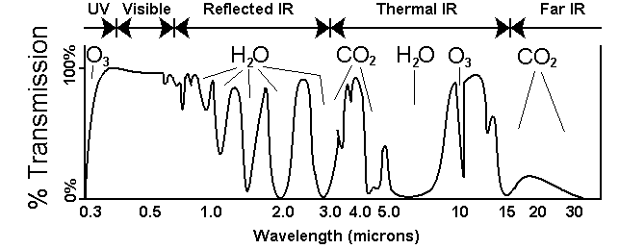

Figure 9: Wavelength versus Atmosphere Transmission Quality (Source: www.rsc.org)

This wavelength met all requirements initially set by the trade study and provided additional features to increase transmission efficiency.

Using the top-down power requirement that limited the power of the transmitting laser to at most 30 watts input, a laser power output could be found using estimated efficiencies. According to commonly found values for laser equipment, the average efficiency was at 25%. This translated to a maximum laser output of 7.5 watts, if no optimizations were used. Although a commonly used phenomenon, occurring in optical amplifiers, is used by laser communication systems. If the optical amplifier is transmitting for a short amount of time, the peak power output is very nearly doubled. Since the optical amplifier would be transmitting a series of 1’s and 0’s, the amplifier would only be transmitting in short pulses, thus allowing a more efficient use of power and setting the laser power output to 14 watts. One drawback to this method requires that a long series 1’s cannot be transmitted. Another draw back common in all optical amplifiers is that if no input is present (0 bits) for a period of time, the device can permanently fail. These two constraints are highly dependent on the optical amplifier, and when a device is made this will need to be taken into consideration.

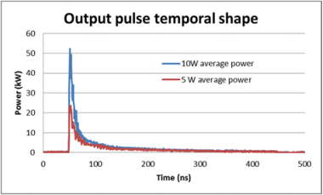

Figure 10: Typical pulse shape for optical amplifier (Source: www.coractive.com)

Since many of the equations in the model of the laser communication system require the wavelength value and output power, setting these allowed for other variables to be found such as the dimensions of the optical apertures. The apertures for the transmitter and receiver determine several limitations of the mission, such as the maximum transmission distance, data rate, and pointing requirements. In order to detect as much light as possible, the receiver aperture would optimally be as large as possible. Since the aperture dimensions are limited by the size of the standard CubeSat, which is 10 centimeters. The optimal receiver aperture diameter is 10cm since this is the only constraint. Finding the transmitter aperture diameter was more involved, since the divergence angle and power output is dependent on the aperture size.

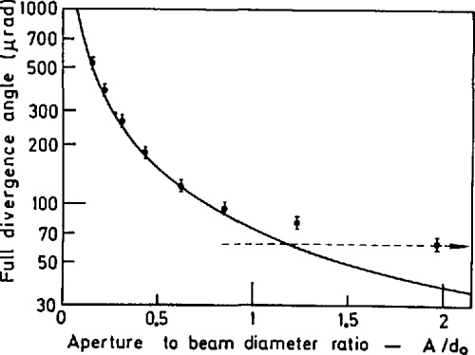

Figure 11: Subsystem Trade Tree

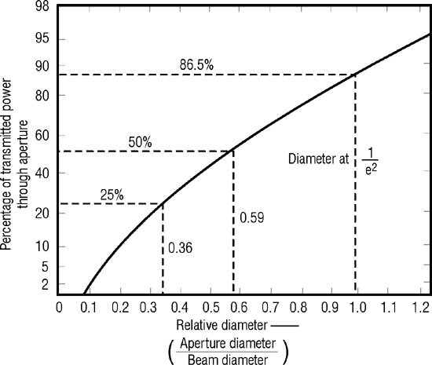

Figure 12: Subsystem Trade Tree

By restricting the beam divergence to a minimum of 0.0083 degrees, which is over two times the ADC control capability, a diameter of 3.12 centimeters was found for the transmission aperture. The power needed by the light sensor varies widely on the specific device, but even the least sensitive sensors could detect light on the order of 10e-5 watts of power. The power received by a receiving satellite was at 0.0015 watts when the distance between them was 500 km. By choosing this at the maximum distance at which the satellites can communicate reliably, still allows for two orders of magnitude margin. The theoretical bandwidth, which also varies on the quality of the apertures and how many photons are reflected, was estimated at 375 Mbps using an aperture quality of 1.44 bits/photon.

# 4.0 Design Details

## 4.1 Baseline Design

After performing the respective trade studies for each subsystem, the final candidates were chosen for the mission. The following trade tree shows the final choices along with the other alternatives for each subsystem.

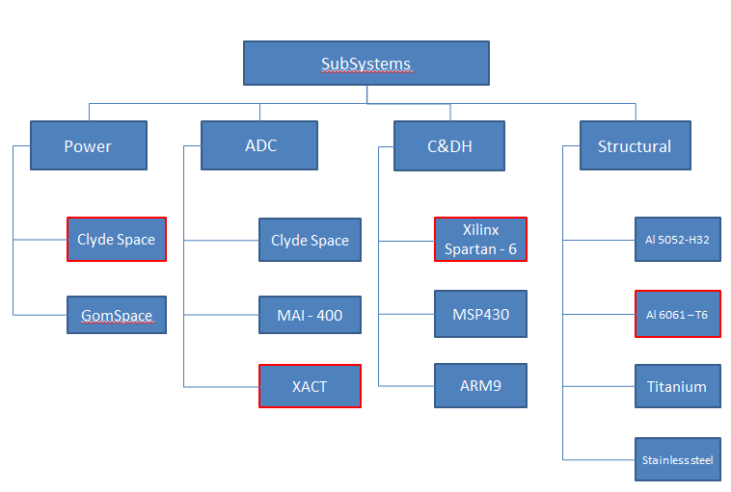

Figure 13: Subsystem Trade Tree

The final choices are outlined in red: the Command and Data Handling subsystem will use the Xilinx Spartan - 6, the Attitude Determination and Control will use XACT, Power will use Clyde Space's power system, and the Structure of the CubeSat will be fabricated using Al 6061 - T6.

## 4.2 Final Design Description

### 4.2.1 Command and Data handling

For the final choice of the C&DH, the Xilinx Spartan-6 processor used by the Q6 Processor board will be used for this mission based on the qualities of the board and heritage missions. The Q6 Processor Board comes consumes roughly 1 Watt of power on average, but will greatly depend on infrastructure and how the FPGA is configured. The board includes space to add Micro SD for temporary storage of communication test result data if communication between the Earth and satellite is not working. The board will interface with the EPS, ADC, Laser communication, and RF communication with custom FPGA I/O interfaces. The interfaces may need to emulate I2C or SPI Communication, but this will be handled by software configuration and custom drivers. Although the Xilinx Spartan-6 is an FPGA, the ability to create a so called soft CPU will allow for the board to take full advantage of a RTOS.

|  |  |  |  |  |  |  |
| --- | --- | --- | --- | --- | --- | --- |
|  | **Computational Bandwidth**  **(w = 1.0)** | **Power**  **(w = 0.1)** | **Comm Bus**  **(w = 1.0)** | **Cost**  **(w = 0.2)** | **Heritage Missions**  **(w = 0.5)** | **Total** |
| **Xilinx Spartan-6** | 1 | -1 | 1 | -1 | 1 | 2.3 |
| **MSP430** | 0 | 1 | 0 | 1 | 1 | 0.9 |
| **ARM9** | 1 | 0 | 1 | 0 | 0 | 2.0 |

Figure 14: Analytical Hierarchy table for C&DH processor

### 4.2.2 Attitude Determination and Control

The XACT system boasts a series of star trackers, an Inertial Measurement Unit (IMU), sun sensors, reaction wheels, and torque rods. The central processor of the XACT unit uses the RS-422 standard for its data interface and allows for multiple reference frames: Inertial, LVLH (Local Vertical/Local Horizontal), Earth-Fixed, and Solar The combination of these instruments and control devices allows for pinpoint pointing accuracy of up to ± 0.003° for its 1st and 2nd axes and ± 0.007° on its 3rd axis. Such accuracy would theoretically allow for successful laser communication at a distance 4500 km (curvature of Earth was accounted for). This pointing accuracy exceeds the required value for the mission scope and would allow for extensive extended operations testing.

Figure _ shows the block diagrams of the different sensors, mechanism, and processors of the XACT unit. Information measured from the different sensors are fed into the Attitude Determination Processor, which utilizes the Kalman Filter method. The Kalman Filter takes all the measured data or "noise" and integrates it, combining them to create a more accurate solution. This process is done recursively until the accuracy of the solution is less than 10 arcseconds. The new solution is then communicated to the Attitude Controller which commands the active control systems (reaction wheels) to make the attitude adjustments. All of this information will be fed into the C&DH subsystem in order to communicate it between the CubeSats as well as the ground station.

The XACT is also only 0.5U (10 cm x 10 cm x 5 cm), which allows for enough space for the CubeSat to house the other subsystems, and has undergone comprehensive testing, including qualifying for NASA GEVS (General Environmental Verification Standards) acceptance levels. XACT is also constructed while satisfying the following requirements: ISO9000/AS9100 (Aerospace quality standard) and NASA-STD-8739.x (NASA Technical Standards). The XACT was also developed specifically for the Air Force Research Laboratory With all that in mind, the TRL of this heritage technology has been determined to be an 8. [1]

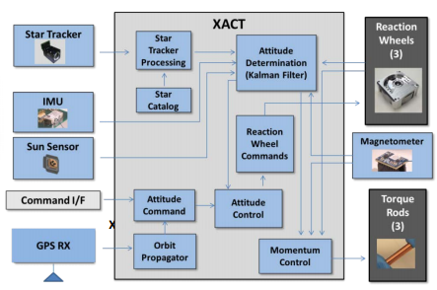

Figure 15: Block Diagram of XACT

### 4.2.3 Power Subsystem

The power subsystem is designed to handle the electrical power needs of the cube satellite for the duration of the mission. The design of the power subsystem is highly dependent on the power required by the laser communication and communication systems utilized. The power subsystem is composed of three main parts, the power board, the batteries, and the solar cells. The solar cells chosen are triple junction GaInP2/GaAs/Ge with a minimum efficiency of 28.3% [2]. The solar panel configuration utilizing a solar panel on each side of the structure plus 2 deployed solar panels will provide power at BOL of 10.31 W in 28oC [2]. The power board selected is the 3U CubeSat EPS from Clyde Space which can interface with up to 6 solar arrays and has 3.3V and 5V busses with over-current protection. The 3U CubeSat EPS also has telemetry via an I2C line [2]. There will be three 30 Whr CubeSat Standalone batteries manufactured by Clyde Space [2]. The batteries are Lithium Polymer batteries with an energy density of approximately 150Wh/kg [2]. The power subsystem has been sized with extra power to account for any. Through the duration of this mission most of the power draw will be from the laser communication system. The cube satellites will run on battery power and will be recharged by the solar panels while in daytime operations. The power budget is sized conservatively to allow for extra power draw in the case of an unforeseen circumstance.

Table 5: Battery Depletion due to Cube Satellite Operations over the first 3 hours



The predicted battery usage in the first day of orbit after the initial test and checkout of the satellite can be seen in Table XX. This predicted battery usage assumes that the batteries will be charged back to 100% after the initial test and checkout. The initial ADC acquisition where the satellites will orient themselves will be completed first. Then the initial laser acquisition and communication will occur for 30 min. Then the data gathered will be transmitted to the ground station and the satellites will go into minimal operations to charge the batteries. Afterwards, the cube satellites will enter the eclipsed portion of their orbit. Here the cube satellites will first communicate with a ground station and then conduct another laser acquisition and communication test for 15 minutes. This process is repeated until the satellites enter the sunlit portion of their orbit.

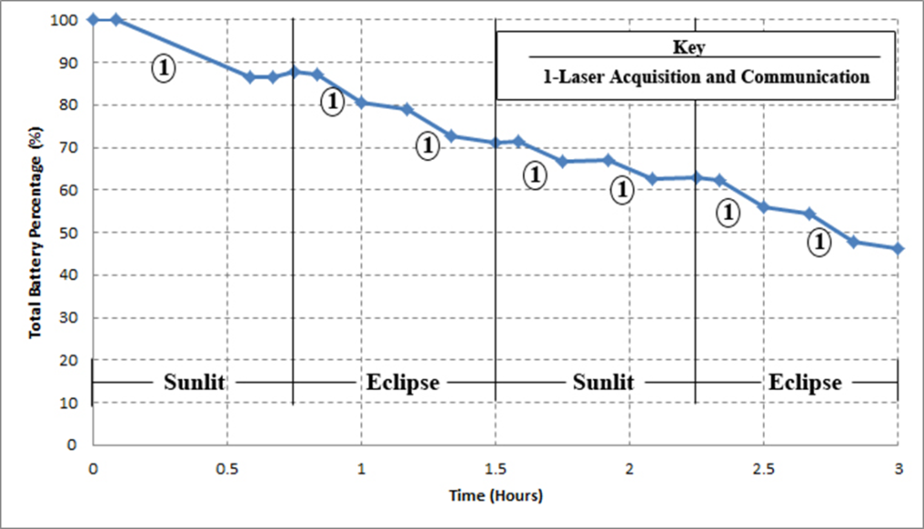

Figure 16: Expected Total Battery Percentage over 3 hours

Figure 16 shows how the batteries will be depleted after 2 orbits. Whenever laser communication operations are used, the slope in the figure becomes more negative. This figure only shows the first 3 hours or 2 revolutions around the Earth.

### 

Figure 17: Expected Total Battery Percentage over 24 hours

Figure 17 shows the battery depletion over 24 hours. The initial 3 hours where laser acquisition and communication is repeatedly used can also be seen in this figure. After which the cube satellites are placed in the minimal operations power mode to charge the batteries. The positive slope indicates charging of the batteries in the sunlit portion of the orbit while the negative slope shows battery losses during the eclipsed portion of the orbit. Once the batteries are charged back to full capacity, laser communication tests will begin again.

### 4.2.4 Communication Subsystem

The decision was made based on power budget specifications, and the need to optimize laser performance, all other system power consumptions must be minimized. Each CubeSat will house a single Helium Radio UHF module for TX and RX.

In addition to the radio boards, each CubeSat will be equipped with an end cap. The end cap houses a set of two 55'' antennas. Therefore, there will be doubly-redundant transmittance and reception capabilities. The end opposite to where the laser aperture is located will house the UHF end cap antenna.

These design decisions were made based on the capability of successfully meeting mission objectives, first and foremost. Also, the design decision was based on the ability to stay within budgetary constraints such as power, volume, and mass. Lastly, Eb/No requirements were not taken into consideration due to minimization of pointing error and space path losses in Low Earth Orbit.

### 4.2.5 Structure and Thermal Subsystem

PROPHECY will have a structural system that is standard for the triple-unit CubeSat dimensions which consists of three payload buses housing all of the subsystems. The housing will be made of aluminum 5052-H32 and aluminum 6061-T6.

The laser will be mounted on one end of the CubeSat’s long axis so there will be a circular window on that end. There will also be structural and electronic interfaces for the deployable antenna. A diagram of the proposed arrangement of components can be seen in the figure below. The laser payload will occupy 1.5U, the ADC subsystem will occupy 0.5U, and the service module which includes power, C&DH, and communication will occupy 1U of the spacecraft.

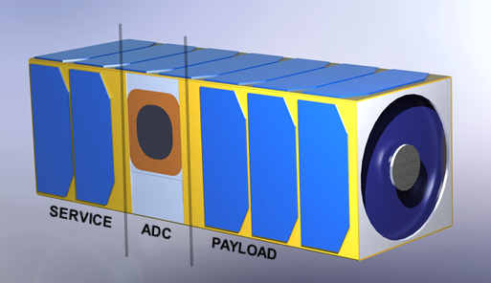

Figure 18: Layout of Subsystems within Structure

Most of the components have previously flown on CubeSat missions before and are rated to withstand temperatures ranging from -40 to 80ºC. The laser has also been rated at these temperatures. A thermal analysis dictates that the most extreme external surface temperatures of spacecraft in LEO will range from -75ºC in eclipse and 24ºC in the sunlit period. The internal components will range from -35 to 40ºC which falls within the appropriate ratings [8]. Generally, CubeSats “do not need to have thermal systems because of their mass and size limitations” [6]. Considering the length and altitude of the PROPHECY mission, a thermal system is not necessary. However, as an extra precaution a Mylar insulation blanket will surround the laser payload. This will help keep the payload within normal operating temperatures during both cold and hot conditions. Heritage suggests that this is one of the most popular passive thermal control systems.

## 

## 4.3 Mass Breakdown

Table 6:. Mass Budget

|  |  |  |  |  |  |  |  |
| --- | --- | --- | --- | --- | --- | --- | --- |
| Element | |  | Level 3 | Level 2 | | | Level 1 |
|  |  |  |  | CBE | Cont. (10%) | Allocated |  |
| 1.0 Laser Payload | | |  |  |  |  | 500.0 g |
| 2.0 Spacecraft Bus | | |  |  |  |  | 3107.5 g |
|  | 2.1 Power | |  | 1303.0 g | 130.3 g | 1433.3 g |  |
|  |  | 2.1.1 Power Module | 83.0 g |  |  |  |  |
|  |  | 2.1.2 Solar Panels | 620.0 g |  |  |  |  |
|  |  | 2.1.3 Batteries | 600.0 g |  |  |  |  |
|  | 2.2 ADC | |  | 700.0 g | 70.0 g | 770.0 g |  |
|  | 2.3 C&DH | |  | 17.0 g | 1.7 g | 18.7 g |  |
|  | 2.5 Communication | |  | 175.0 g | 17.5 g | 192.5 g |  |
|  | 2.6 Structure | |  | 580.0 g | 58.0 g | 638.0 g |  |
|  | 2.7 Wires and Connectors | |  | 50.0 g | 5.0 g | 55.0 g |  |
| 3.0 Spacecraft Mass | | |  |  |  |  | 3607.5 g |
| 4.0 Margin | |  |  |  |  |  | 392.5 g |
| 5.0 Total Mass Capacity | | |  |  |  |  | 4000.0 g |

## 4.4 Power Budget

The power budget analysis separates operations of the cube satellite in to various power modes to efficiently manage energy consumption throughout the life of the mission. A total of 4 different power modes were created and labeled Full Usage, Laser Communication Operations, Minimal Operations, and Eclipsed Operations.

**Table 7: Full Usage Power Budget**



Table 8: Laser Communication Operations Power Budget



Table 9: Eclipsed Operations Power Budget



Table 10: Minimal Operations Power Budget



The Full Usage power budget analysis shows what the overall power consumption would look like if each Prophecy cube satellite ran all of its systems at full power. In the Laser Communication Operations power budget, the power consumption of the communication subsystem is reduced to 2 W so that radio communication is still possible however, the focus of this mode is to allow the cube satellites to focus on laser acquisition and communication. The minimal operations and eclipsed operations power modes are similar except for the communication power consumption. The minimal operations mode will be used when charging the batteries of the cube satellite are the main priority. The eclipsed operations power mode is used for communication with the ground stations when the cube satellites are in the eclipsed portion of their orbits. The ADC and CD&H systems power consumption do not change in any of the power modes since they are essential at all times.

## 4.5 Volume Breakdown

Table 11: Volume Budget

|  |  |  |  |  |  |  |  |
| --- | --- | --- | --- | --- | --- | --- | --- |
|  |  |  |  | Level 2 | |  |  |
| Element | |  | Level 3 | CBE | Cont. | Allocated | Level 1 |
| 1.0 Payload (Laser) | | |  |  |  |  | 500.0 cc |
| 2.0 Spacecraft Bus | | |  |  |  |  | 1693.6 cc |
|  | 2.1 Power | |  | 900.0 cc | 90.0 cc | 990.0 cc |  |
|  |  | 2.1.1 Power Module | 90.0 cc |  |  |  |  |
|  |  | 2.1.2 Batteries | 810.0 cc |  |  |  |  |
|  | 2.2 ADC | |  | 500.0 cc | 50.0 cc | 550.0 cc |  |
|  | 2.3 C&DH | |  | 10.0 cc | 1.0 cc | 11.0 cc |  |
|  | 2.5 Communication | |  | 129.6 cc | 13.0 cc | 142.6 cc |  |
| 3.0 Total Component Volume | | |  |  |  |  | 2193.6 cc |
| 4.0 Margin | | |  |  |  |  | 806.4 cc |
| 5.0 Total Volume Capacity | | |  |  |  |  | 3000.0 cc |

## 4.6 Risk Analysis

Several mission risks have been identified. They have been organized and placed in the risk matrix below.

Table 12: Risks

|  |  |  |  |  |
| --- | --- | --- | --- | --- |
| Risk Type | Call Sign | Risk | Likelihood | Severity |
| Spacecraft | SP-1 | Being unable to communicate with spacecraft | 2 | 3 |
| Spacecraft | SP-2 | Jettison and orbit insertion issues | 2 | 3.5 |
| Personnel | PER | Loss of mission human knowledge | 3 | 2 |
| Payload | PAY | Failure to gather science mission data | 2 | 4 |

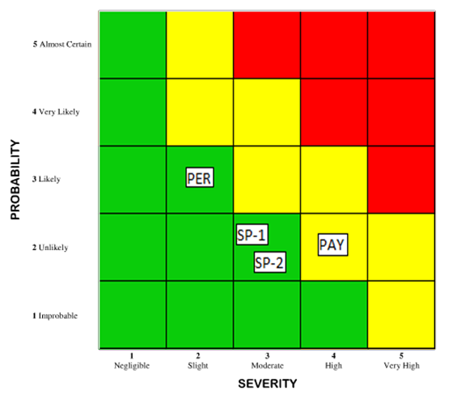

Figure 19: Risk Matrix

## 4.7 Cost Estimation

The total cost for the mission has been broken down beginning with Lasercom Research and Development Costs.

Beginning with Lasercom Hardware, $600,000 has been allocated to develop 2 Flight Units and 2 Engineering Design Units (EDUs). From there, the cost was broken down further into subcategories for the purpose of breaking down engineering development. These subcategories include the Transmitter, Receiver, and Optics & Housing and each of these subcategories have been allotted $200,000 for hardware. Secondly, $500,000 has been allocated to engineering the lasercom hardware. This estimate was based off of the development for the RACE radiometer. With a 30% cost margin, this lends the total development cost to be $1.43M.

|  |  |  |
| --- | --- | --- |
| **LASERCOM DEVELOPMENT COSTS** | | |
| Element | Level 2 | Level 1 |
| 1.0 Lasercom Hardware Costs |  | $600,000.00 |
| 1.1 Transmitter Costs | $200,000.00 |  |
| 1.2 Receiver Costs | $200,000.00 |  |
| 1.3 Optics and Housing | $200,000.00 |  |
| 2.0 Labor Costs |  | $500,000.00 |
| 2.1 Engineering | $500,000.00 |  |
| 3.0 Subtotal |  | $1,100,000.00 |
| 4.0 Margin |  | $330,000.00 |
| 5.0 Lasercom Development Cost |  | $1,430,000.00 |

Table 13: Lasercom development costs

Next, we move into cost estimation for a single PROPHECY flight unit. This section was broken down into the three modules, beginning with the Service Module. Due to the fact that all of this equipment is heritage equipment, the actual hardware cost estimates for this section is likely to be very accurate. For the ADC Module, Blue Canyon Technologies quoted the PROPHECY mission for $125,000 per unit, with an 8 month lead time and no additional sensors or actuators will be needed. Lastly, for the Payload module, the $357,500.00 figure is actually the Lasercom development costs divided by four. This is because this cost will iterate four times due to the fact that there will be two spacecraft Flight Units and two EDUs. Finally, the cost for each structure after milling and thermal provisions (such as Mylar) is estimated to be $6000 and lastly, miscellaneous items (such as wire harnesses, fasteners, staking, etc.) is estimated to cost about $3500. With a 30% cost margin, this leads the total cost of a single flight unit to be $747,873.56.

|  |  |  |
| --- | --- | --- |
| **COST ESTIMATE FOR PER PROPHECY CUBESAT** | | |
| Element | Level 2 | Level 1 |
| 1.0 Service Module (1U) |  | $83,287.35 |
| 1.1 EPS batteries and controller | $15,150.00 |  |
| 1.2 Comm. Radios | $7,254.45 |  |
| 1.3 C&DH Computer | $25,901.25 |  |
| 1.4 ISIS Antenna | $12,781.65 |  |
| 1.5 Solar Panels | $22,200.00 |  |
| 2.0 ADC Module (0.5U) |  | $125,000.00 |
| 2.1 BCT XACT System | $125,000.00 |  |
| 2.2 Additional AD Sensors | $0.00 |  |
| 2.3 Additional AC Actuators | $0.00 |  |
| 3.0 Payload Module (1.5U) |  | $357,500.00 |
| 3.1 Laser Transmitter and Receiver | $357,500.00 |  |
| 4.0 Structure and Thermal |  | $6,000.00 |
| 4.1 CubeSat Structure | $5,000.00 |  |
| 4.2 Thermal Provisions | $1,000.00 |  |
| 5.0 Additional |  | $3,500.00 |
| 5.1 Wire Harnesses and Fasteners | $3,000.00 |  |
| 5.2 Staking, coating, and misc. | $500.00 |  |
| 6.0 Subtotal |  | $575,287.35 |
| 7.0 Margin |  | $172,586.21 |
| 8.0 Total Cost |  | $747,873.56 |

Table 14: Cost Estimate

Lastly, the total mission costs stem from creating two satellites (PROP-1 and PROP-2) each consisting of a Flight Unit and an EDU. The EDU is the same cost as the Flight Unit before a cost margin is implemented. This is because it is a unit used for testing and the flight quality requirements are not as strict. Due to the fact that PROP-1 and PROP-2 are identical satellites, the $1.323M figure appears twice in the total mission costs. On top of this is the Ground Support Equipment costs, which consists of interface equipment used for satellite testing. Adding all of these costs together, we come up with a figure of $2,652,071.81.   
Note, the labor costs for assembly and engineering of the CubeSat bus (and not the Lasercom Payload) are not present due to the fact that this is to be developed by a university small-sat team, and the labor costs are usually dropped in lieu of the educational opportunity and work experience.

|  |  |  |
| --- | --- | --- |
| **TOTAL MISSION COSTS** | | |
| Element | Level 2 | Level 1 |
| 1.0 PROP-1 |  | $1,323,160.91 |
| 1.1 Flight Unit | $747,873.56 |  |
| 1.2 Engineering Design Unit | $575,287.35 |  |
| 2.0 PROP -2 |  | $1,323,160.91 |
| 2.1 Flight Unit | $747,873.56 |  |
| 2.2 Engineering Design Unit | $575,287.35 |  |
| 3.0 Ground Support Equipment |  | $5,750.00 |
| 3.1 GSE Computers | $2,000.00 |  |
| 3.2 Interface Equipment | $3,000.00 |  |
| 3.3 GSE Margin | $750.00 |  |
| 4.0 Total Mission Hardware Costs |  | $2,652,071.81 |

Table 15: Total Mission Costs

# 5.0 Summary and Conclusions

The increased data transmission needs as technology becomes more complex creates a problem for satellite communications, since the data transfer is often throttled by the bandwidth of radio frequencies. Studies have shown that laser communication systems are the solution to this problem. A laser communication system for nanosatellites to communicate with other satellites or to establish a groundlink needs to be demonstrated.

PROPHECY has completed a preliminary design for two cube satellites to test a laser communication system in low earth orbit. The mission will be completed by two identical cube satellites that will communicate with each other, ISS, and a ground station. Trade studies were completed to determine the best options for each subsystem of the cube satellite that meet the design requirements.

# 6.0 Evaluation of Overall Design**6.1 Strengths**

The single greatest strength of our design is the use of heritage equipment that has been proven in past missions. Specifically, anything that is not experimental (i.e. the laser) has a proven track record of successful space flight and is therefore flight proven. The power system, radio communication system, C&DH, and ADC systems are all at a flight readiness level of 6 or greater. Furthermore, using two spacecraft as a means of completing this mission further increases overall redundancy, as the entire mission can be completed with only one fully operating laser.

Another strength of this system is its cost and mission timeline. The cost of the mission itself is relatively low cost when compared to similar missions of a larger scale. Furthermore, due to the fact that this mission is to ride on a secondary payload to the ISS, the timeline is very flexible, and the mission can begin at any time.

6.2 Weaknesses

The technology readiness level for our primary experiment, the optical laser, is not up to par with the rest of the mission. Due to the fact that the technology has not been tested nor fully developed for a CubeSat application, it is difficult to guarantee mission success. That said, more research would need to be completed and the technology would need to be verified by industry experts in order to increase the technology readiness level for the optical laser. To that end, two optical lasers have been implemented (one on each spacecraft) in order to increase redundancy and mitigate potential error or faults that come about. The mission only requires one operational optical laser in order to confirm mission success.

# 7.0 References

[1] "XACT" [Online] [http://bluecanyontech.com/product/xact/]

[2] "CubeSat Electric Power Systems" [Online]

[http://www.clyde-space.com/cubesat_shop/eps]

[3] “Laser Communications Relay Demonstration,” NASA, October 2012.  [Online]

     [http://www.nasa.gov/pdf/742122main_LCRDFactSheet3.pdf. Accessed 2/14/14.]

[4] “MAI-400” [Online] [http://www.miniadacs.com/miniadacs_012.htm]

[5] “Aerospace Specifications Metals” [Online] [http://www.aerospacemetals.com/]

[6] Arestie, Hudson, Imken, et al. “Science Enabling CubeSat Constellation Final Report,” ASE

374L, December 2011.

[7] “CubeSat Attitude Determination and Control Systems” [Online]

[http://www.clyde-space.com/cubesat_shop/adcs]

[8] Dinh, D. “Thermal Modeling of Nanosat” [Online]

[http://scholarworks.sjsu.edu/cgi/viewcontent.cgi?article=7740&context=etd_theses]

# 8.0 Appendices

## 8.1 Team Structure and Organization Chart

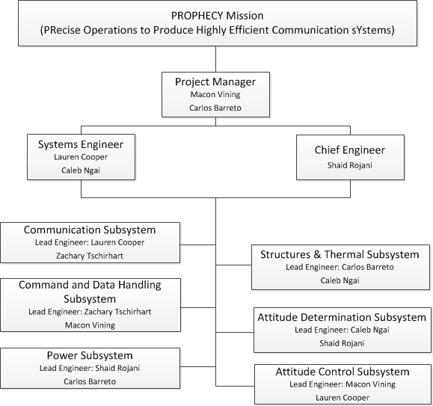

Figure 4. Team Structure and Organization

## 8.2 Individual Team Member Contributions

**Carlos Barreto**

Carlos worked on the structures and thermal subsystems. He researched the materials that would work best for the mission and performed the thermal analysis necessary to determine whether a thermal system was needed or not. He also created the mass and volume budget tables and helped with the editing and formatting of the final report.

**Zachary Tschirhart**

Zach worked on the Command and Data Handling subsystem and the laser communication system. He also helped with the communication part and the formatting of the report. He compared several systems based on quantitative attributes and decided on a processor that would fit the needs of the mission. He also created a calculator, which provided rough power requirements for the laser communication payload.

**Caleb Ngai**

Caleb worked on the Attitude Determination and Control subsystems. He researched several heritage systems and performed an analysis based on specific selection criteria to determine the best choice. He also formulated the trade tree as well as helped edit the report.

**Macon Vining**

Macon did research about overall system compatibility. Macon also designed the logo, wrote and designed the mission CONOPS and mission scope, revised the executive summary, wrote the two primary studies of the heritage research, created the cost analysis sections and wrote the introduction and established all needs and requirements.

**Shaid Rojani**

Shaid researched requirements for a power subsystem and subsequently power subsystems compatible with the requirements. He created the power budget by obtaining power draw from the other subsystems. Shaid also wrote the power subsystem, summary and conclusion, and compiled the appendices. He also assisted in formatting and the mass budget.

**Lauren Cooper**

Lauren drafted the executive summary. She conducted the trajectory analyses and evaluated deployment options. She researched the laser communication system and did a trade study on the effects of lasers on the human eye. She was in charge of the communication subsystem that did not include the experimental laser communication system.

## 8.3 Team Member Resumes









Macintosh HD:Users:zacharytschirhart:Downloads:Zachary-Tschirhart.pdf

